# CS 255 Business Requirements Document Template

## System Components and Design

### Purpose

* The Client is DriverPass and the purpose of the system design, as a high-level overview, is to build a system that will handle everything to do with users taking online classes and practice tests as well as on-the-road training.
* In more detail, the system is to help users access data from anywhere whether its online or offline. The system is to be able to update data offline as well as to be able to have access to the data online from any computer or mobile device, but with minimizing possible redundancies. The system will also need to be able to download documents that can be used with Excel.

### System Background

* DriverPass with the owner being Liam*,* is a startup driver training company created to fill a need for better driver training because many people tend to fail their driving test at the DMV.
* DriverPass wants the system to allow users to have access to online classes and practice tests to help with taking the DMV test. The problem that this system can help fix is the high percentage of people who fail the test.
* The components needed for this system, is a User Interface using the owner’s design, that will be support custom packages for the customers such as package one, six hours in car training, package two, eight hours in car as well as in person training and package three, twelve hours in car with trainer and in-person lessons plus online access.
* User security measures or user sessions that have different access levels and permissions based on user profiles like an administrative profile for IT, owners, or other admin staff that want to maintain the system, a secretary type of profile that will have access to add, modify, or delete any appointment, and a customer profile that will have access to make reservations will also be needed.
* A cloud-based architecture for backups, security and to help obtain the functionality to allow the system to be accessed from any computer or mobile device. Mobile first development, which is a method to design the user interface to work on mobile devices first and then work the way up to non-mobile devices like a laptop or desktop. The system also needs to be an internet-based program so that the program will work from any computer or mobile as well as on any mobile device.
* Lastly the program needs to be connected to the DMV so that it can always be up to date with the latest DMV information.

### Objectives and Goals

* The objective of this system is to create a learning environment that students can access from any device that’s connected to the internet. This system should be able to allow multiple types of users to access the system and support user log in sessions. This system should be able to stay up to date on the latest DMV information. It should also be always connected to a cloud-based service that can handle data backups as well as security. The user interface needs to be based of the client’s design as well as being able to provide proper support for the three training levels while also providing edit access for admin to change said training levels if needed.
* The goal of the system is to allow access for authorized profiles to be able to customize the packages and have a flexible system with the understanding that for major module changes, a developer may be needed. Another goal of the system is to have functionality to be able to create user sessions or profiles that consist of roles like, students/customers, the secretary, the IT officer, and the owner and each of these roles will have different permissions. The system would also need to have functionality for a registration function that would include first and last name, address, and phone numbers as well as the state and a place to enter credit card information. Also, the system should be able to be connected to the DMV so that the school will have the most up to date information. Lastly the system needs to be cloud based with all backups and security being handled by the cloud. The system will need a database to store user information so I would think the task after that would be to integrate a database into the program. The system will have credit card information, so security measures like encryption, which is a process of protecting users’ information will need to be put into place. A client/server set up will also help to enhance proper security. The end goal will be to have a program that can work on all devices and the program will also have a database to hold all data that will be accessed from the server.

## Requirements

### Nonfunctional Requirements

#### Performance Requirements

* The system needs to be support a LMS (Learning Management System), that will allow for online classes and practice tests
* The system needs to have data accessible anywhere, online as well as offline. Utilizing a web-based format that can be accessed using a web browser and utilizing downloadable applications so that data can be interacted with while offline.
* The system must be flexible, so that packages can be customized like adding new ones or removing current ones.
* The system needs to be easily adaptable to run on a computer or mobile device so that the data can be accessed anywhere that is online.
* The system needs to run off the web making use of a cloud provider service to handle backup and security
* The system needs to be scalable meaning easily able to add new features for future use.

#### Platform Constraints

* The system will need a developer or a system analyst to add or remove modules, it can’t be built so that a nondeveloper can do this task easily
* The system will need to run on any or most of the popular browsers as well as being compatible with at least the three major operating systems, Linux, MacOs, and Windows. While also being compatible with most mobile devices.
* The system will need to have a database would be used to store information like user sign in credentials, course offerings, as well as payment methods and transactions history.

#### Accuracy and Precision

* The system shall have a configurable roles and permissions like a full access level for the owner, a almost full access level as well as maintenance level access for the IT department, an administrative access level for the admin staff like a secretary and a user access level from students and teachers.

* Created usernames are not case sensitive but passwords need to be case sensitive.
* The system should inform admin staff or owner of system problems or password reset immediately.

#### Adaptability

* The system shall have easy integration with most any existing software and systems. The LMS will need to be able to work with multiple types of operating systems for all users to be able to access no matter what they have.
* Owner access level will have complete access like resetting forgotten passwords and blocking user access for when someone leaves.
* IT access level will have access to system maintenance as well as system updates.
* Admin access level will have access to making appointments, where they can modify or cancel appointments.
* User access level will have access only to their appointments, where they can modify or cancel their own appointments.

#### Security

* The system must have the most up to date security protection to meet industry standards for cloud security as well as data privacy. The LMS needs to have security put in place to protect the users log in and passwords as well as personal and professional data.
* The system must require a non-case sensitive username and a case-sensitive password.
* The system shall use encryption libraries like Bcrypt which is a password hashing algorithm that adds multiple layers of security.
* The system must be set up as a client/server set up to add additional protection by having all data accessed using the server which is separate than the client side which is attached to the browser networks.
* User sessions should be created with time-outs so that if there is a brute force attack, the user session can be terminated, and the user account can be locked and then repaired or deleted.
* If a user forgets their password, there should be security questions answered and then a notification goes out to the owner so that he can reset the password.

### Functional Requirements

* The system shall have an easy to use set up for course creation so that the LMS allows teachers to easily deliver course content to the learners.
* The system shall show students interactive features like discussion forums, video conferencing, and clickable courses. This function is how students and teachers would interact with course work as well as each other.
* The system shall support management access, views, and function, and security roles for each position like teach, student admin, IT. The LMS system must have functionality to be able to support and distinguish the different roles that will access the system.
* The system must be able to allow users to access the LMS system and features via a mobile friendly interface as well as in a browser. The system needs to have functionality to allow for not only desktop/laptop browser access but will also be needed for mobile devices due to most if not all users may want to use one of the many mobile devices that are at hand.
* The system shall allow data to be extracted and imported through user interface. The LMS must allow students to upload and download as well as teachers uploading and downloading assignments.
* The system shall have a Robust Analytics and Report Generation. The LMS needs to have easy access to a dashboard or pull down that has progress reports and other learner data.

### User Interface

* The user interface needs to have the logo, spots allocated for online test progress, a registration place to enter information like first and last name, address, city, state, and zip as well as the phone number.
* The user interface also needs to allocate space for drivers notes, a special needs section as well as a driver and student photo.
* The user interface will be used by students and drivers interacting with training schedules, administrators, modifying and maintaining appointments, IT handling system maintenance and updates and the owner that has a general access over everything and each user will more than likely interact with this interface through mobile as well as through a browser.
* The user interface will also list current available packages, package one is six hours in a car with a trainer, package two is eight hours in a car with a trainer and an in-person lesson and package three is twelve hours in a car with a trainer, an in-person lesson *plus* access to our online class.

### Assumptions

* User has a valid Log in to access the system. It is important for each user to be uniquely identifiable within the system. If not, they are not allowed access.
* Users have access to an internet connection as well as a browser. This is a web-based application, all users would be required to have an internet connection in order to access the system.

### Limitations

* System will stop working once internet connection is lost. The LMS relies on an internet connection to operate. Without this connection the system would not be able to connect to its servers.
* The LMS would require a database connection to be able to access vital information like courses, grades and user information login credentials.

### Gantt Chart

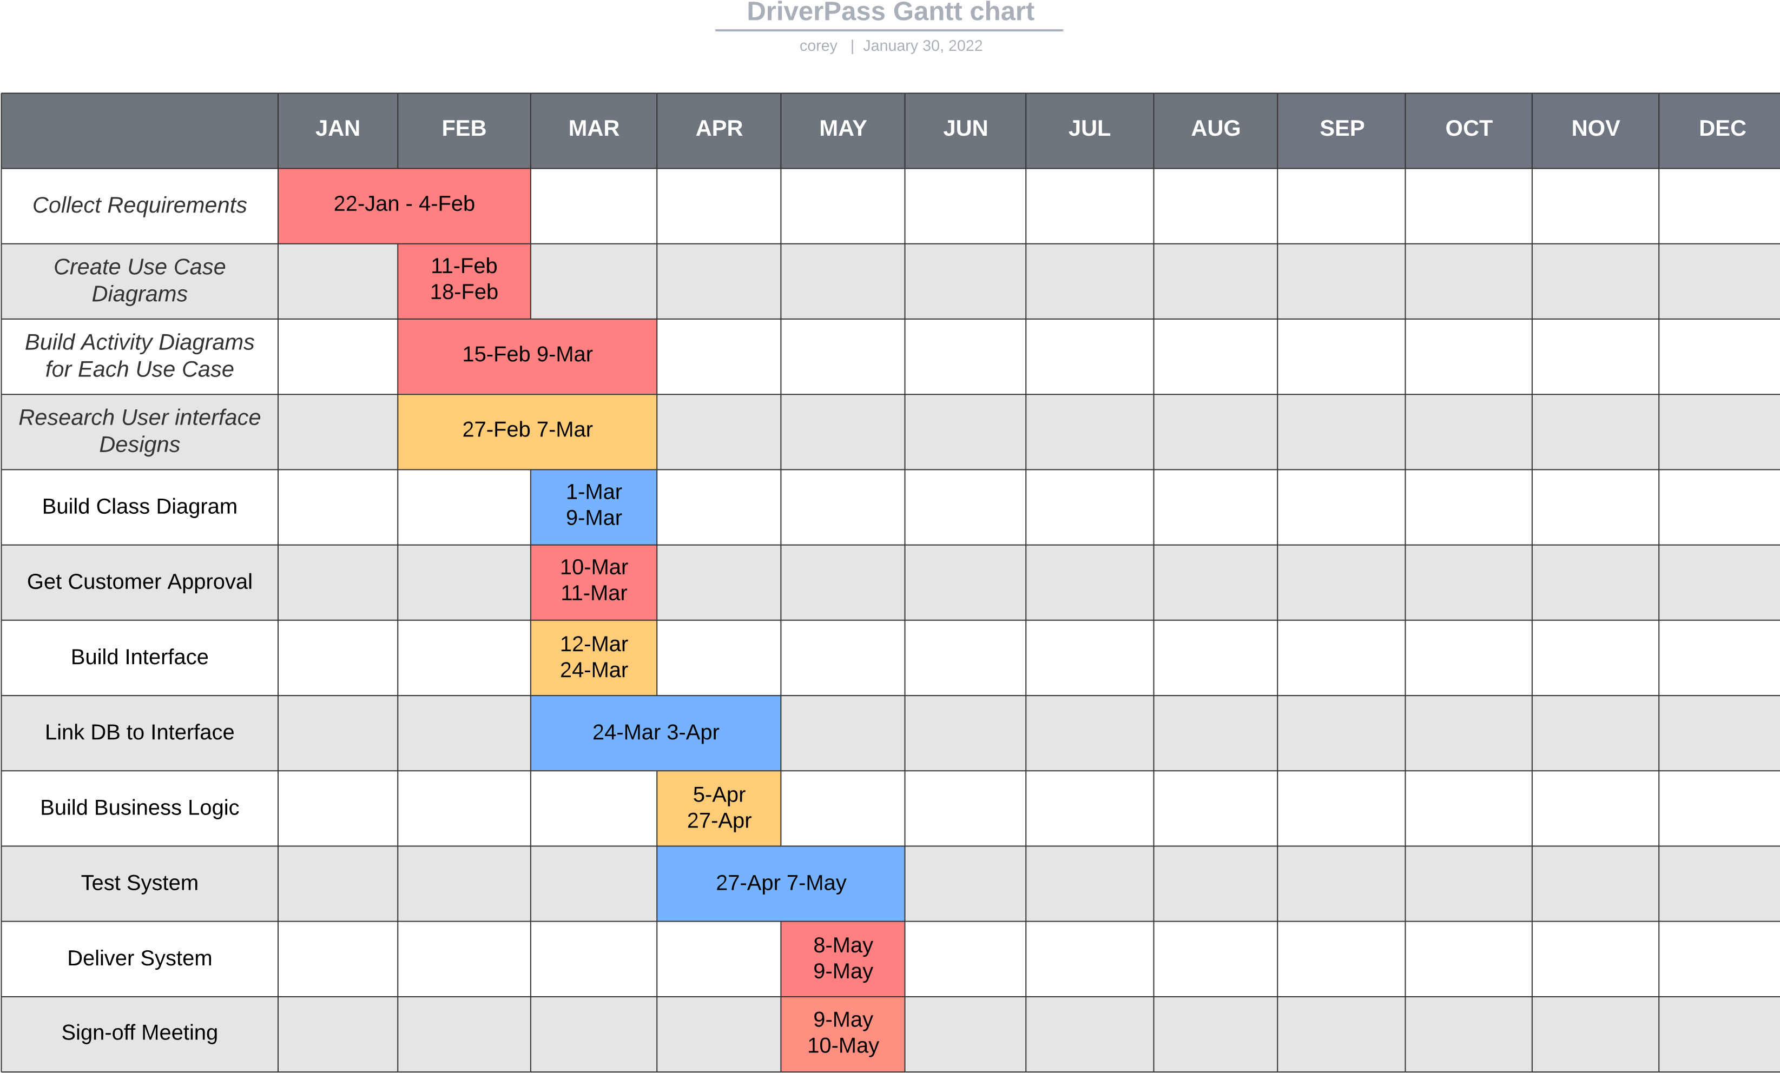

*L*

*e*

*g*

*e*

*n*

*d*

*~~:~~*

P

r

o

d

u

c

t

T

e

a

m

D

e

v

e

l

o

p

m

e

n

t

t

e

a

m

D

e

v

e

l

o

p

m

e

n

t

t

e

a

m

2